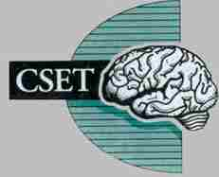

2019 Annual Meeting of the Central Society of
Electroneurodiagnostic Technologists

CSET ANNUAL MEETING
APRIL 26 & 27, 2019

Radisson Milwaukee West – Milwaukee, WI
Radisson Milwaukee West
2303 N Mayfair Rd
Wauwatosa, WI 53226
Phone:
RESERVATIONS: +1 (800) 333-3333 (US/Canada Toll-free)
TELEPHONE: +1 (414) 257-3400
FAX: +1 (414) 257-0900

Website:
http://www.radisson.com/milwaukee-hotel-wi-53226/wiwauwat
Use Block Code: CSET

Room Rate:
Standard room types guest rooms……….$ 119.00

NOTE:
You must specify you are a CSET participant and use Block Code: CSET to receive the SPECIAL RATE. Reservations must be made by March 29th to receive the group rate. Please call or go on-line to make reservations.

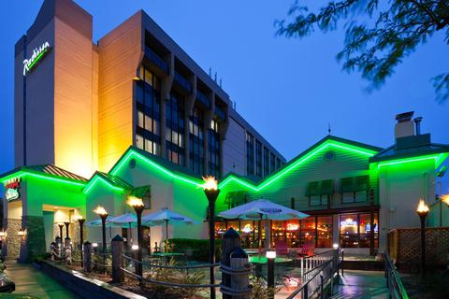
President:
Sara Batson
Batson.sara@mayo.edu

Sectary/Treasurer
Pat Trudeau

Vendor Chairperson
Shawn Carter-Brown

Local Arrangers
Peggy O’Neill
Michelle McHugh

Applying for ASET CEU’s for EEG, EMU/cEEG, and IONM courses

Applying for BRPT CSTE’s for Polysomnography course

CSET SOCIAL

Where: Radisson West, room TBA

When: Friday April 26, 2019

What’s served: Hors d’oeuvres and Cash Bar

WHO: All CSET attendees, speakers, and vendors are invited to attend.

Please stop by to join us. There is no additional charge for attending the social.

Vendor booths will be on site during the days of the meeting.
We want to encourage you to take opportunity to visit the vender booths to check out the variety of equipment and supplies available.

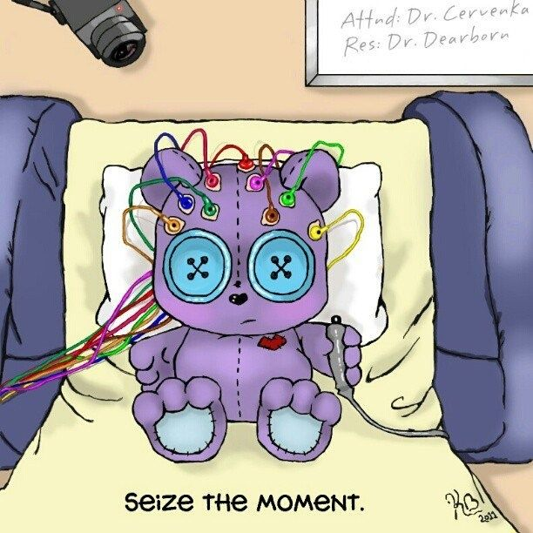

Thank you to the vendors who played a vital role in sponsoring
the 2019 Annual CSET Meeting.

Friday, April 26, 2019
Course 1: IONM
Course Director: Patty Warf, MS, CNIM, FASNM, LSSGB
& Michelle McHugh, CNIM, R.EEGT.

08:00-08:45 Understanding of Patient Burns and Sources
Brett Netherton MS, CNIM, FASNM, FACNS

08:45-09:45 Principles of Simulation for IONM Applications
Larry, Wierzbowski AuD, DABNM, FASNM

09:45-10:00 Vendor Break

10:00-10:45 Mapping the Brain and Spinal Cord
Tom Epplin Zapf PhD, CNIM

10:45-11:30 Communicating “ALERTS": Tactful Delivery Under Stress Derek Stanfield, D.C., CNIM

11:30-13:00 CSET Business Meeting/Lunch

13:00-14:00 Neurosurgery Update on Arnold Chiari Procedures and Neuromonitoring Findings
Dr. Dan Heffez

14:00-15:00 Medical Negligence: Case Reviews and Open Discussion
Sabrina Faust R.EEG/EPT, CNIM, CLTM

15:00-15:20 Vendor Break

15:20-16:20 How Does clinical Outcomes Drive Performance Improvement?
Cheryl Wiggins AuD, D.ABNM , CNIM

16:20-16:45 All Speakers Panel Discussion

Saturday, April 27, 2019
Course 1: IONM
Course Director: Patty Warf, MS, CNIM, FASNM, LSSGB
& Michelle McHugh, CNIM, R.EEGT.

08:00-08:45 Aneurysm Surgery
Dr. Bhattacharjee

08:45-09:30 (LQP) –TcMEP During Aneurysm Surgeries
Ernesto Lima MD, D. ABNM, CNIM

09:45-10:00 Vendor Break

10:00-10:45 RLN MEP’s
Matt Cotton MS, CNIM, FASNM

10:45-11:30 Opioids Effects on the CNS and Impact on Neurodata Acquisition
MeChelle Vance CNIM, LSSGB

11:30-12:30 Lunch

12:30-13:30 Corticobulbar MEP’s
James Watt BS, CNIM, R.EPT

13:30-14:30 Critical IONM Alerts
Tom Epplin Zapf PhD, CNIM

14:30-15:00 (LQP)-TcMEP using DTS (Double Train Stimulation)
Technique During Spine Surgery
Ernesto Lima MD, D. ABNM, CNIM
Marcia Davidson R.EEG/EP T, CNIM, RN,
R.PSG T., RET

15:00-16:00 CranioMetric Points and Brain Anatomy/Head Measuring
Hands on Workshop
Ernesto Lima MD, D. ABNM, CNIM
Marcia Davidson R.EEG/EP T, CNIM, RN,
R.PSG T., RET

16:00-16:15 All Speaker Panel Discussion

Friday April 26, 2019
Course 2: EEG
Course Directors: Pat Trudeau R.EEG T., CLTM, FASET

08:00-09:00 Interesting Case Studies from the EMU
Shawn Carter-Brown, R.EEG T., CLTM, CNIM

09:00-10:00 Normal EEG Patterns, Variants and Benign Patterns
Anna-Marie Beck, MOL, R.EEG T., FASET

10:00-10:15 Vendor Break

10:15-11:00 Electrodes and Skin Integrity
Leah Hanson R.EEG/EP T.

11:00-11:30 Updating Job Descriptions and Job Compensation
Marcia Davidson R.EEG/EP T, CNIM, RN,
R.PSG T., RET

11:30-13:00 CSET Business Meeting/Lunch

13:00-14:00 Artifacts
Jennifer Vierkant R.EEG/EP T., CLTM, RPSGT

14:00-15:00 ILAE Epilepsy Classification
Lee Wolfinbarger R.EEG T.

15:00-15:30 Vendor Break

15:30-16:30 Benign Pediatric Epilepsy: Characterization, Classification
and EEG Features:
Amy Caccamo R.EEG/EP T., CLTM

16:30-16:45 Closing Comments

Saturday, April 27, 2019
Course 2: EMU/cEEG
Course Directors: Cindy Nelson, R.EEG T.

08:00-09:00 Continuous Video EEG Monitoring in the ICU
Dr. Chris Anderson

09:00-09:45 Emergency Room Visits Recovery diagnosis of Psychogenic
Non-Epileptic Events (PNEE) as a Diagnosis
Linda Allen BSN, RN

09:45 -10:00 Vendor break

10:00-11:00 The Hidden Information in EEG Recordings – Part of our Future
Dr. Kurt Hecox

11:00-11:30 How to Build an ENDT Business
Keith Morgan R.EEG T.

11:30-13:00 Lunch

13:00-14:00 Continuous EEG for Prognostication after Cardiac Arrest
Dr. Janel Schneider

14:00-15:00 Why cEEG in the ICU
Monte Molenkamp BS, R.EEG T., CNIM

15:00-16:00 CLTM Board Prep
Jennifer Vierkant R.EEG/EP T., CLTM, RPSGT

Friday April 26, 2019
Course 3: Polysomnography
Course Directors: Theresa Buechl RPSGT, R.EEG T.

08:00-09:00 Developing the Role of the CSE in the Sleep Center
Marla Van Lanen, RRT, RPSGT, CCSH

09:00-10:00 Mountains to Move: Principles of Noninvasive Positive Pressure Ventilation
Deb Medin MEd, RRT, RPSGT

10:00-10:15 Vendor Break

10:15-11:30 Physiological Morbidity CHF and COPD
Greg Miller, BS, RPSGT

11:30-13:00 CSET Business Meeting/Lunch

13:00-14:00 Physiology Behind Respiratory Effort and Airflow
Dave Stockdale BA, RPSGT, CPFT

14:00-15:00 Using CO2 Monitoring in Sleep Studies
Marla Van Lanen, RRT, RPSGT, CCSH

15:00-15:15 Vendor Break

15:15-16:15 Utilizing HST Program to Increase In Lab Sleep Studies
Shannon Dean

16:15-17:00 Insomnia
Catherine C. Loomis, Ph.D., C.B.S.M.

CSET MEMBERSHIP SCHOLARSHIP

Two 2019 CSET Scholarships are available.
All applicants must be members of CSET.
CSET Officers and Board Members are not eligible for
the scholarship. This will include a two-day registration fee waiver.

Send application to:
Pat Trudeau
10131 Westby Rd
Marshfield, WI 54449
PAT.TRUDEAUEEG@GMAIL.COM

DUE BY April 19, 2019

Please Print
Applicant’s Name: ______________________________________

Employer Name: _______________________________________

Street Address:_________________________________________

City:_____________________State:_____________Zip:________

Work Phone:___________________________________________

E Mail Address:_________________________________________

Please attach a brief essay on your goals in attending the 2019 CSET meeting along with how this scholarship will help achieve them. Notification of award will be made at arrival for registration.

CSET OUTSTANDING EDUCATOR AWARD

Do you know a CSET member that has a reputation for commitment to education in the field of electroneurodiagnostics? Would you like to nominate them for recognition at the Annual 2019 CSET Meeting in Milwaukee, Wisconsin?

Please submit a brief essay with your nomination before April 19, 2019 to:

Patti Baumgartner
CSET Outstanding Educator Award Chair
E-mail: patti_baum@sbcglobal.net

Friday Courses, April 26, 2019
Payment sent on or before April 19, 2019
Course 1: IONM
CSET Member Non-Member Student*
$125.00_____ $170.00 _____ $50.00 _____
Course 2: EEG
CSET Member Non-Member Student*
$125.00_____ $170.00_____ $50.00_____
Course 3: Polysomnography
CSET Member Non-Member Student*
$125.00_____ $170.00_____ $50.00_____

Payment sent after April 19, 2019
Course 1: IONM
CSET Member Non-Member Student*
$135.00_____ $180.00 _____ $50.00 _____
Course 2: EEG
CSET Member Non-Member Student*
$135.00_____ $180.00_____ $50.00_____
Course 3: Polysomnography
CSET Member Non-Member Student*
$135.00_____ $180.00_____ $50.00_____

Saturday Courses, April 27, 2019

Payment sent on or before April 19, 2019

Course 1: IONM

CSET Member Non-Member Student*

$125.00_____ $170.00 _____ $50.00 _____

Course 2: EMU/cEEG

CSET Member Non-Member Student*

$125.00_____ $170.00 _____ $50.00 _____

Payment sent after April 19, 2019
Course 1: IONM
CSET Member Non-Member Student*
$135.00_____ $180.00_____ $50.00_____
Course 2: EMU/cEEG
CSET Member Non-Member Student*
$135.00_____ $180.00_____ $50.00_____

*Students shall be defined as any individual currently enrolled in a program reviewed by the Committee on Accreditation for Education in Electroneurodiagnostic Technology (CoA-END) and accredited by the Commission on Accreditation of Allied Health Education Programs. Verification of student status must accompany application. Verification will also be required at sign in.

Membership Dues enclosed $25 ($15 students) $ ______________

Registration Fee enclosed $_________________________________
Make checks payable to CSET. There will be a $25 returned check fee.

For Credit Card Payments- there is a 2.75% charge for credit card payments

Card Type (Circle one) Mastercard Visa Discover American Express

Card# _______________________________ Exp date__________

Security#_________(3 digit number on back of card or 4 digit number on Front of American Express card)

Billing name and address (please fill in completely)

Name:_____________________________________________________

Street Address:_____________________________________________

City:____________________________State______Zip_____________

REGISTRATION INFORMATION (Please Print Legibly)

Name: (For name tag)________________________________________________

Credentials________________________________________________________

Company/Institutional Affiliation_________________________________________

Mailing Address:_____________________________________________________

Preferred Phone # _________________________________Work or Home (Circle)

E-mail Address:______________________________________________________

Your e-mail is required in order for you to access handouts from Dropbox.

Send to:
Pat Trudeau
10131 Westby Rd
Marshfield, WI 54449
PAT.TRUDEAUEEG@GMAIL.COM

